Inter-Rater Reliability of Delirium Severity Ratings Using a Standardized Clinical Assessment of Delirium in At-Risk Patients
Running title: Assessment of Delirium Severity

Anna MacKay-Brandt, PhD ^{a,b}
Tammy T. Hshieh, MD, MPH ^{c,d,e}
Kenneth Boockvar, MD, MS ^{f,g}
Edward R. Marcantonio, MD, MSc ^{h,e}
Catherine C. Price, PhD, ABPP ^{i,j}
Rebecca Avila-Rieger, PhD ^{b,k}
Juliana S. Burt, MS ^{i}
Benjamin A. Chapin, MD ^{i,j}
Wingyun Mak, PhD ^{b,l}
Kerry Palihnich, BA ^{h}
Douglas Tommet, MS ^{m}
Richard N. Jones, ScD ^{m}
Tamara G. Fong, MD, PhD ^{d,e,n} *
Sharon K. Inouye, MD, MPH ^{d,e,o} *
for the BASIL II Study Group
(*=co-senior authors)
a The Nathan Kline Institute for Psychiatric Research, Clinical Research, Orangeburg, NY, USA
b The New Jewish Home Research Institute on Aging, New York, NY, USA
c Division of Aging, Department of Medicine, Brigham and Women’s Hospital, Boston, MA, USA
d Hinda and Arthur Marcus Institute for Aging Research, Hebrew SeniorLife, Boston, MA, USA
e Harvard Medical School, Boston, MA, USA
f Division of Gerontology, Geriatrics, and Palliative Care, University of Alabama, Alabama, USA
g Geriatrics Research, Education and Clinical Center, Birmingham VA Health Care System, Birmingham, Alabama, USA
h Divisions of General Medicine and Gerontology, Department of Medicine, Beth Israel Deaconess Medical Center, Boston, MA, USA
i Perioperative Cognitive Anesthesia Network (PeCAN) for ADRD, Department of Clinical and Health Psychology, Department of Anesthesiology, University of Florida, Gainesville, Florida, USA
j Geriatric Research Education and Clinical Center, Malcom Randall VA, Gainesville, FL, USA
k Department of Child and Adolescent Psychiatry, Hassenfeld Children’s Hospital/New York University Langone Health, New York, NY, USA
l Geriatrics and Palliative Care, Icahn School of Medicine at Mount Sinai, New York, NY, USA
m Department of Psychiatry and Human Behavior, Warren Alpert Medical School, Brown University, Providence, RI, USA
n Department of Neurology, Beth Israel Deaconess Medical Center, Boston, MA, USA
o Department of Medicine, Beth Israel Deaconess Medical Center, Boston, MA, USA

Corresponding Author/Request for Reprints:
Tamara G. Fong, M.D, Ph.D.
Aging Brain Center, Institute for Aging Research, Hebrew SeniorLife
1200 Centre Street; Boston, MA 02131 USA
Phone: (617) 971-5390; Fax (617) 971-5339
Email: tfong@bidmc.harvard.edu (not for publication)

Acknowledgements
Sponsors Role/Funding: In part by grants from the National Institute on Aging grants no. P01AG031720 (SKI), R33AG071744 (SKI), R01AG044518 (SKI/RNJ). Dr. Marcantonio’s time was supported in part by grants no. K24AG035075 (ERM), R01AG030618 and R01AG051658. Dr. Price’s time was additionally supported in part by grant no. K007AG066813. Dr. Inouye holds the Milton and Shirley F. Levy Family Chair at Hebrew SeniorLife/Harvard Medical School.
Ethics Approval: The BASIL II study was approved by the Institutional Review Board (IRB) of Beth Israel Deaconess Medical Center (BIDMC), Boston, MA (No. 2020P001113). All participants provided written informed consent.
Abstract (250 words)

Objectives: Delirium severity is an important measurement for clinical monitoring, pathophysiologic studies, and treatment trials. We examined inter-rater reliability of delirium severity ratings by trained clinical assessors using standardized protocols across different clinical settings.
Design: Prospective, multisite observational study
Setting: Acute medical inpatient, elective surgical inpatient, and nursing home
Participants: Subsample (n=46) of participant cases for a reliability analysis conducted on 954 paired ratings by 7 clinical assessors across sites. The subsample was selected from older adults (n=488; 46% delirium, 59% dementia) enrolled in the Better Assessment of Illness (BASIL) II study.
Measurements: Clinical assessors were provided standardized summaries including cognitive test results and delirium-specific assessments and used this information to rate delirium severity on a 0-10 scale. Paired agreement was defined as delirium severity scores within 2 points. Inter-rater reliability and variability were evaluated before and after a consensus meeting, utilizing a modified Delphi approach to achieve agreement by prespecified criteria.
Results: Clinical assessors demonstrated high inter-rater agreement in delirium severity ratings (weighted kappa, κ=0.84), which improved following consensus discussions (κ=0.93). Bland-Altman analysis showed no evidence of systematic disagreement across the full range of severity scores (linear trend for differences over average of two rater scores, b=0.03, 95% confidence interval, -0.13, 0.20).
Conclusions: Trained clinical assessors demonstrated high inter-rater reliability in delirium severity ratings across a reliability sample that included patients with dementia and a wide range of delirium severity. These findings support feasibility of structured clinical assessment approaches for generating reproducible delirium severity measurements in multisite research studies.

INTRODUCTION
Delirium is a common and serious medical syndrome in older adults. Among patients with Alzheimer’s Disease and Related Dementias (ADRD), delirium occurs with greater frequency, severity, and associated morbidity.¹⁻⁴ Delirium severity, defined as the intensity or burden of delirium features, has emerged as a clinically meaningful outcome for patient monitoring, risk stratification, and evaluating response to treatment.⁵ Graded severity ratings provide information beyond presence/absence indicators, enabling more precise tracking of subthreshold symptoms, symptom fluctuation, and degrees of improvement over time.^{6,7}
Despite growing interest in delirium severity as an outcome, there is limited evidence on the reliability of delirium severity ratings in research settings across diverse care environments, and the reliability of such ratings has been questioned given their highly variable manifestations. High quality studies rely on expert panel adjudication for reference standard delirium and related diagnoses,^{7,8} but standardized clinical assessment protocols provide another opportunity for research standardization that has not been well characterized. This is particularly important for multisite research studies that depend on reproducible, high-quality data across sites.
The Better Assessment of Illness (BASIL) II study is a multisite prospective cohort study designed to develop and validate delirium severity instruments in older adults with and without ADRD.⁹ As part of this effort, trained clinical assessors (CAs) conducted standardized delirium assessments using structured cognitive and functional tools, including the Confusion Assessment Method (CAM),¹⁰ Montreal Cognitive Assessment (MoCA),¹¹ and informant interviews, across three care settings: acute medical, elective surgical, and post-acute nursing home. CAs were clinicians and experienced clinical researchers and included at least one delirium or dementia expert at each site. Our goal in this report was to assess overall agreement of delirium severity rating among CAs, explore the effect of consensus discussion on inter-rater reliability, and examine whether agreement varied by level of delirium severity and the presence of dementia.
METHODS
Study Design and Procedures
Study Sample. This study was conducted within the Better Assessment of Illness (BASIL) II study, an NIH-funded prospective cohort study specifically designed to develop and validate new delirium severity instruments for persons with and without dementia. An important part of the data collection for the BASIL II study was completed by a team of 7 clinical assessors across 3 study sites. The present analysis was conducted to evaluate the reliability of data collection by the clinical assessors, which was essential to assure the validity of the overall BASIL II study. Participants were enrolled from three clinical settings: (1) acute medical inpatient units at Beth Israel Deaconess Medical Center (BIDMC), Boston, MA (2) elective surgical inpatient services at the University of Florida Hospital (UF), Gainesville, FL and (3) nursing home (long-term and post-acute care) at The New Jewish Home (TNJH), New York City, NY. After completion of a gold standard rating of delirium severity (described below) a subsample of 46 cases was selected for the reliability sample; this sample size was selected based on the inclusion of 7 assessors for which the à priori target number of cases to ensure statistically stable results was estimated to be between 25 and 50 cases.^{13,14} Cases were selected sequentially to ensure representation of both delirium positive and negative cases across all study sites. Each of the 46 cases were rated by 7 clinical assessors resulting in 21 unique pairwise comparisons; this resulted in 966 paired ratings across 46 participants (Supplemental Figure 1). Missing ratings from one clinical assessor (for two participants) resulted in loss of 12 pairwise comparisons, yielding a final reliability sample of 954 paired ratings. Gold standard assessment of delirium for the full BASIL II sample employed an expert panel adjudication process, described previously.^{9,12} The gold standard diagnoses were used in the present study. All study procedures, including informed consent, were approved by the BIDMC Institutional Review Board with ceded review from UF and TNJH. All participants or their legal representatives provided informed consent.
Clinical Assessor Procedures. The Clinical Assessors (CAs) were clinicians and experienced clinical researchers, including neuropsychologists (n=3), psychologist (n=1), neurologist (n=1), mental health counselor (n=1), and clinical project manager (n = 1), who had experience in the diagnosis of delirium and dementia. All CAs underwent centralized training and standardization procedures, including didactic instruction, observed ratings, weekly case review with the Site Leader, and bimonthly all-site check in meetings. The CAs conducted structured interviews and ratings of participants as part of the BASIL II study.⁹
For the reliability study, the seven CAs independently reviewed identical packets containing a uniform set of information, including demographic data, in-person cognitive performance (MoCA,¹¹ Severe Impairment Battery [SIB-8]¹⁵), delirium features/severity (CAM,¹⁰ CAM-Severity [CAM-S]¹⁶), and informant-based tools (Family Assessment of Delirium [FAM-CAM],¹⁷ Eight-item Informant Interview to Differentiate Aging and Dementia [AD8],¹⁸ Delirium Rating Scale Revised 98 [DRS-R-98]¹⁹). Medical record documentation of medical comorbidities and medications were also reviewed for each of the 46 cases. Delirium severity was rated using a 0–10 scale, with anchors corresponding to absent (0), subsyndromal (1–3), mild-to-moderate (4–6), and severe delirium (7–10). Clinical assessors were instructed to base their ratings solely on the structured assessment materials provided in the case packets. The CA ratings for delirium severity were compared, and initial agreement was considered achieved according to the pre-specified threshold of 5 out of 7 clinical assessors agreeing on the presence or absence of delirium, and no more than a 2-point range of disagreement among delirium severity scores (scored on a 0-10 point scale). Following initial ratings, 13 cases achieved agreement, and 33 cases without consensus were discussed in consensus meetings. These meetings were conducted in 11 sessions over 7 months, discussing 2-9 cases at each. See Supplemental Figure 2 for assessment details and clinical assessor consensus process.

Statistical Analysis
The analytic plan was pre-specified and implemented independently of the clinical assessors. We used a multi-method approach to evaluate inter-rater reliability of the clinical assessor delirium severity ratings.
We evaluated inter-rater reliability for delirium severity scores (0-10 scale) using all possible paired combinations of the 7 clinical assessors (n = 954 unique pairs). We examined both Pearson correlation coefficients and weighted kappa coefficients (with quadratic weights) to summarize the agreement among pairs and confirmed that both approaches yielded identical results. We report these statistics as weighted kappa coefficients. These agreement statistics were calculated before and after the structured consensus discussion to assess its effect on reliability. For the binary classification of delirium (present/absent), we also calculated kappa (κ) before and after consensus to assess diagnostic agreement. To address whether reliability differed by the presence of dementia, we repeated weighted κ and percent agreement analyses stratified by dementia status (present vs. absent, per gold-standard adjudication). We also computed mean absolute differences between paired rater scores as a complementary continuous index of disagreement on the 0-10 severity scale.
We used Bland-Altman analysis²⁰ to examine agreement between rater pairs across the full range of severity (0-10). For each plot, we regressed the difference in scores (Rater A – Rater B) on the pairwise mean score to test whether disagreement varied by severity level. A slope that is approximately 0 indicates no systematic bias in agreement across the severity spectrum. To reduce potential sampling bias and improve representativeness, we applied analytic weights using entropy balancing²¹ to more closely match the subsample distribution to the full BASIL II sample on site and delirium severity rating.
All analyses were conducted using R (version 4.3.2).

RESULTS
For the 954 paired ratings, delirium severity scores ranged from 0-9 (M = 2.4, SD = 2.6), representing a wide range of clinical severity. Characteristics of the 46 cases comprising the reliability sample appear in Supplemental Table 1.
Figure 1 illustrates the high inter-rater agreement in delirium severity rating prior to and following the consensus process. The weighted kappa was κ=0.84 (95% confidence interval, CI 0.82, 0.86) indicating strong consistency across assessors. Following the consensus meeting, the weighted kappa increased to κ=0.93 (95% CI 0.92, 0.94). Table 1 shows a crosstab of paired delirium presence (clinical assessor diagnosis) before (κ=0.77, 95% CI 0.73, 0.81) and after consensus (κ=0.81, 95% CI 0.77, 0.85), both indicating excellent agreement.²²
Reliability was also examined separately for patients with and without dementia (Supplemental Table 2). Inter-rater agreement was high and comparable across both strata. The weighted kappa was κ=0.85 (95% CI 0.82, 0.88) in cases without dementia and κ= 0.84 (95% CI 0.81, 0.86) in cases with dementia prior to consensus, improving to κ=0.94 and κ=0.93 after consensus. Percent agreement reached 100 in both strata following consensus. Mean absolute differences between paired rater scores were higher in dementia cases (1.20 pre, 0.77 post) than non-dementia cases (0.84 pre, 0.52 post) but remained within the prespecified 2-point rater agreement window.
To evaluate whether rating discrepancies varied as a function of delirium severity, Bland-Altman analysis was conducted. There was no significant association between the mean severity score and absolute disagreement across rater pairs before (linear regression coefficient, b=0.03, 95% CI -0.13, 0.20) and after consensus (b=-0.01, 95% CI -0.13, 0.12) suggesting that disagreement was not systematically greater at lower or higher ends of the severity spectrum (Figure 2).

CONCLUSION
This reliability study embedded in the larger BASIL II cohort shows that trained clinical assessors can follow standardized protocols to produce highly reliable delirium severity ratings across diverse care settings. Inter-rater agreement was strong prior to consensus discussion and improved further after the structured consensus process. Importantly, agreement did not vary across levels of delirium severity, supporting the consistency of this approach across the full clinical spectrum. Agreement was also similarly high in cases with and without dementia, supporting reliability of this approach in the population for whom delirium severity measurement is most clinically needed and most challenging.
While expert panel adjudication is considered the reference standard for delirium diagnosis, it may not be feasible for large-scale studies, or those operating under resource constraints. The BASIL II study is one of few studies to detail the expert panel adjudication process.²³ To enable rigorous validation of delirium diagnosis and the development of delirium severity assessment tools, the study team employed a standardized approach to the initial clinical assessment using a fixed protocol of measures administered by assessors with study-specific training and weekly meetings across study-sites to discuss ratings. There is limited evidence on the inter-rater reliability of structured clinical assessments of delirium conducted by trained clinical assessors who vary in experience and qualifications.⁹ Our findings extend previous work by demonstrating the reliability of delirium severity ratings when assessors are trained and supported with standardized protocols, even in the absence of a consensus process.
The strength of this study is the use of structured summaries – including cognitive testing (e.g., MoCA, SIB-8), standardized delirium assessments (e.g., CAM, CAM-S), informant interviews – which allowed assessors to rate cases using uniform, high-quality data, and the availability of expert reference standard diagnoses. This design minimized contextual bias and may extrapolate to real-world scenarios in which site-based clinicians evaluate delirium based on available assessment tools.
A few limitations should be noted. First, the reliability study was conducted on standardized summaries, which were condensed in-person assessments. A bedside clinical impression was incorporated into the standardized materials for review but remained constant across each rater. While this approach minimizes contextual biases, it may not fully reflect clinical variation that may be appreciated at the bedside.²⁴ Second, this relatively small reliability sample (n=46 cases) is sufficient for inter-rater reliability estimation but not well-suited for comparisons across study sites. For site and other levels of analysis, see Boockvar et al.’s report of expert panel ratings using the full BASILII cohort. Third, assessors were part of a research team with dedicated training and time, limiting generalizability to routine clinical care. However, the high reliability achieved across independent raters from multiple disciplines highlights the feasibility of this approach for research studies requiring graded measurement of delirium severity.
In conclusion, clinical assessors trained with standardized protocols demonstrated strong inter-rater reliability of delirium severity ratings across varied settings and clinical profiles. These findings support the use of structured clinical assessments to generate reproducible data in geriatric care research and highlight the utility of rater training in multicenter studies. Delirium severity is increasingly recognized as a robust predictor of clinical outcomes. Future work using highly reliable, graded measurement of delirium has the potential to capture valuable symptom information and positively impact clinical monitoring, pathophysiologic studies, and treatment trials.

Authorship Statement: We affirm that all the co-authors listed contributed significantly to the preparation of this manuscript and approve this final version to be published. We thank the BASIL II study group for their contributions to this work.
Author Contributions: Drs. MacKay-Brandt, Hshieh, Boockvar, Marcantonio, Price, Tommet, and Fong contributed to analysis and interpretation of data and preparation of manuscript. Drs. Jones and Inouye contributed to study concept and design, acquisition of participants and/or data, analysis and interpretation of data, and preparation of manuscript.

BASIL II Study Group
[Presented in alphabetical order; individuals listed may be part of multiple groups]
Principal Investigators (Multi-PIs): Sharon K. Inouye, MD, MPH (Multiple PI, HSL, BIDMC, HMS); Richard N. Jones, ScD (Multiple PI, Brown University)
Co-Investigators: Kenneth S. Boockvar, MD, MS (TNJH, UA, BVA); Tamara Fong, MD, PhD (HSL, BIDMC, HMS); Wingyun Mak, PhD (TNJH, ISM); Edward R. Marcantonio, MD, SM (BIDMC, HMS); Catherine C. Price, PhD, ABPP-CN (UF); Eva M. Schmitt, PhD (HSL)
Gold Standard Panel: Kenneth S. Boockvar, MD, MS (TNJH, UA, BVA); Tamara Fong, MD, PhD (HSL, BIDMC, HMS); Edward R. Marcantonio, MD, SM (BIDMC, HMS); Eran Metzger, MD (HSL, BIDMC, HMS); Catherine Price, PhD, ABPP-CN (UF)
Clinical Assessors: Rebecca Avila-Rieger, PhD (TNJH); Juliana Burt, MS (UF); Benjamin Chapin, MD (UF); Rejoice Dhliwayo, BS (BIDMC); Kristin Hamlet, PhD (UF); Yael Koren, PhD, RN (BIDMC, HSL); Anna MacKay-Brandt, PhD (TNJH, NKI); Wingyun Mak, PhD (TNJH, ISM); Mariam Mufti, MD (UF); Kerry Palihnich, BA (BIDMC); Estefania Perera, BA (UF); Catherine Price, PhD, ABPP-CN (UF)
Research Associates and Study Coordinators: Amina Atef Abdelalim (BIDMC); Sabaina Ahmed (UF); Liliane Fanburg (BIDMC); Erin Formanski (UF); Cole Heine (HSL); Margret Howard (TNJH); Faith Kimmet (UF); Julianna Liu (HSL); Gina Michael (BIDMC); Kathryn Pendleton (UF): Abena Prempeh (TNJH); Emily Quig (HSL); Louis Shaevel (BIDMC); Meghan Shanahan (HSL); Hannah Shanes (HSL); Mackenzie Topper (HSL); Peter Wang (BIDMC); Michelle Ward (BIDMC)
Data Management and Statistical Analysis Team: Douglas Tommet, MPH (Brown University); Thomas Travison, PhD (HSL, HMS); Guoquan Xu, MD, PhD (HSL)

Abbreviations: BIDMC, Beth Israel Deaconess Medical Center; BVA, Birmingham VA Health Care System, Birmingham, Alabama; BWH, Brigham and Women’s Hospital; FOI, Florida Orthopedic Institute; HMS, Harvard Medical School; HSL, Hebrew SeniorLife; ISM, Icahn School of Medicine at Mount Sinai; NKI, Nathan Kline Institute for Psychiatric Research, Orangeburg, NY; PI, principal investigator; TNJH, The New Jewish Home; UA, University of Alabama, Birmingham, Alabama; UF, University of Florida; USF, University of South Florida

Data Sharing Statement: The data that support the findings of this study are available on request from the corresponding author. The data are not publicly available due to privacy or ethical restrictions.
Conflict of Interest: The authors report no conflicts with any product mentioned or concept discussed in this article.

References
1. Fong TG, Jones RN, Shi P, et al. Delirium accelerates cognitive decline in Alzheimer disease. Neurology. 2009;72(18):1570-1575. doi:10.1212/WNL.0b013e3181a4129a

2. Inouye SK, Westendorp RG, Saczynski JS. Delirium in elderly people. Lancet. 2014;383(9920):911-922. doi:10.1016/S0140-6736(13)60688-1

3. LaHue SC, Douglas VC, Miller BL. The one-two punch of delirium and dementia during the COVID-19 pandemic and beyond. Front Neurol. 2020;11:596218. doi:10.3389/fneur.2020.596218
4. Fong TG, Davis D, Growdon ME, Albuquerque A, Inouye SK. The interface between delirium and dementia in elderly adults. Lancet Neurol. 2015;14(8):823-832. doi:10.1016/S1474-4422(15)00101-5
5. Vasunilashorn SM, Fong TG, Helfand BKI, et al. Psychometric properties of a delirium severity score for older adults and association with hospital and posthospital outcomes. JAMA Netw Open. 2022;5(3):e226129. doi:10.1001/jamanetworkopen.2022.6129

6. Vasunilashorn SM, Marcantonio ER, Gou Y, et al. Quantifying the severity of a delirium episode throughout hospitalization: the combined importance of intensity and duration. J Gen Intern Med. 2016;31(10):1164-1171. doi:10.1007/s11606-016-3671-9
7. Jones RN, Cizginer S, Pavlech L, et al. Assessment of instruments for measurement of delirium severity: a systematic review. JAMA Intern Med. 2019;179(2):231-239. doi:10.1001/jamainternmed.2018.6975
8. Devlin JW, Sieber F, Akeju O, et al. Advancing delirium treatment trials in older adults: recommendations for future trials from the Network for Investigation of Delirium: Unifying Scientists (NIDUS). Crit Care Med. 2025;53(1):e15-e28. doi:10.1097/CCM.0000000000006514

9. Hshieh TT, Chapin BA, Mak W, et al. Better Assessment of Illness study (BASIL) II for delirium severity: study design, variables, and methods. J Geriatr Psychiatry Neurol. 2026;39(1):79-89. doi:10.1177/08919887251343604
10. Inouye SK, van Dyck CH, Alessi CA, Balkin S, Siegal AP, Horwitz RI. Clarifying confusion: the confusion assessment method. A new method for detection of delirium. Ann Intern Med. 1990;113(12):941-948.
11. Nasreddine ZS, Phillips NA, Bedirian V, et al. The Montreal Cognitive Assessment, MoCA: a brief screening tool for mild cognitive impairment. J Am Geriatr Soc. 2005;53(4):695-699. doi:10.1111/j.1532-5415.2005.53221.x
12. Boockvar KS, Marcantonio ER, Price CC, et al. Gold standard assessment of delirium severity in patients with dementia: evaluation of an expert panel adjudication process. J Alzheimers Dis. 2026;110(3):1204-1213. doi:10.1177/13872877261422418.
13. McHugh ML. Interrater reliability: the kappa statistic. Biochem Med (Zagreb). 2012;22(3):276-282. doi:10.11613/BM.2012.031

14. Tractenberg RE, Yumoto F, Jin S, Morris JC. Sample size requirements for training to a kappa agreement criterion on clinical dementia ratings. Alzheimer Dis Assoc Disord. 2010;24(3):264-268. doi:10.1097/WAD.0b013e3181d489c6
15. Schmitt FA, Saxton J, Ferris SH, Mackell J, Sun Y. Evaluation of an 8-item Severe Impairment Battery (SIB-8) vs the full SIB in moderate to severe Alzheimer's disease patients participating in a donepezil study. Int J Clin Pract. 2013;67(10):1050-1056. doi:10.1111/ijcp.12188
16. Inouye SK, Kosar CM, Tommet D, et al. The CAM-S: development and validation of a new scoring system for delirium severity in 2 cohorts. Ann Intern Med. 2014;160(8):526-533. doi:10.7326/M13-1927
17. Steis MR, Evans L, Hirschman KB, et al. Screening for delirium using family caregivers: convergent validity of the Family Confusion Assessment Method and interviewer-rated Confusion Assessment Method. J Am Geriatr Soc. 2012;60(11):2121-2126. doi:10.1111/j.1532-5415.2012.04200.x
18. Galvin JE, Roe CM, Powlishta KK, et al. The AD8: a brief informant interview to detect dementia. Neurology. 2005;65(4):559-564. doi:10.1212/01.wnl.0000172958.95282.2a

19. Clark CM, Ewbank DC. Performance of the Dementia Severity Rating Scale: a caregiver questionnaire for rating severity in Alzheimer disease. Alzheimer Dis Assoc Disord. 1996;10(1):31-39.
20. Bland JM, Altman DG. Measuring agreement in method comparison studies. Stat Methods Med Res. 1999;8(2):135-160. doi:10.1177/096228029900800204
21. Hainmueller J. Entropy balancing for causal effects: a multivariate reweighting method to produce balanced samples in observational studies. Polit Anal. 2012;20(1):25-46. doi:10.1093/pan/mpr025
22. Fleiss JL, Levin B, Paik MC. The measurement of interrater agreement. In: Statistical Methods for Rates and Proportions. 3rd ed. John Wiley & Sons; 2003:598-626.
23. Oh ES, Rosenberg PB, Wang NY, Sieber FE, Neufeld KJ. Delirium detection methodologies: implications for outcome measurement in clinical trials in postoperative delirium. Int J Geriatr Psychiatry. 2022;37(3). doi:10.1002/gps.5695
24. Fick DM, Hodo DM, Lawrence F, Inouye SK. Recognizing delirium superimposed on dementia: assessing nurses' knowledge using case vignettes. J Gerontol Nurs. 2007;33(2):40-47; quiz 48-49. doi:10.3928/00989134-20070201-09

FIGURE CAPTIONS
Figure 1. Agreement of delirium severity rating before (left panel) and after (right panel) consensus. Scatterplot of delirium severity rating agreement between rater A (horizontal axis) and rater B (vertical axis), shown before (left) and after (right) consensus process. Axis tick labels indicate delirium severity (0-10) and the number of ratings is noted in parentheses. The weighted kappa (κ) between rater A and rater B delirium severity ratings (0-10) prior to the consensus process was 0.84 (95% CI: 0.82, 0.86). After the consensus process, the κ was 0.93 (95% CI 0.92, 0.94).
Figure 2. Bland Altman plot of variability in agreement as a function of delirium severity before (left panel), and after (right panel) consensus process. Differences in agreement (y-axis) are shown as a function of average severity ratings, comparing pairs of raters, before (left) and after (right) consensus process The linear trend lines show systematic differences in agreement. Regression coefficients are not importantly different from 0 in both panels b (95% confidence interval) = 0.03 (-0.13, 0.20) before and b = -0.01(-0.13, 0.12) after consensus process. This suggests there were no systematic differences in level of agreement across the spectrum of delirium severity.

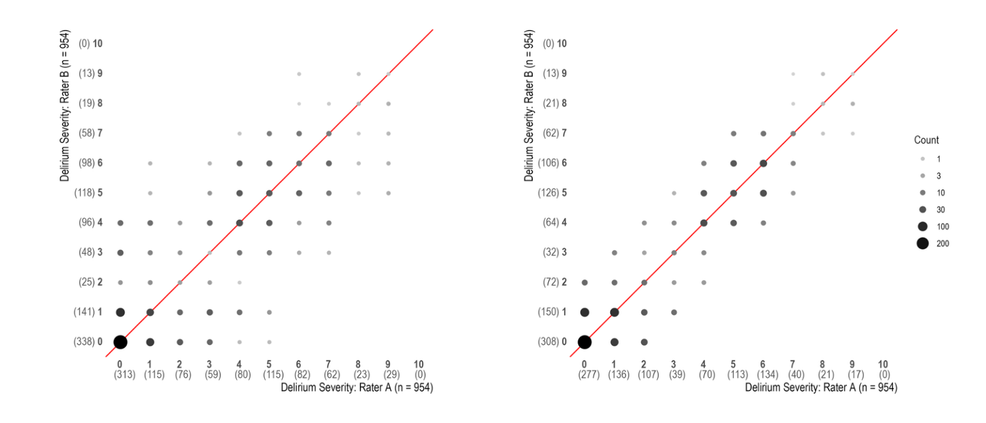
Figure 1. Agreement of delirium severity rating before (left panel) and after (right panel) consensus. Scatterplot of delirium severity rating agreement between rater A (horizontal axis) and rater B (vertical axis), shown before (left) and after (right) consensus process. Axis tick labels indicate delirium severity (0-10) and the number of ratings is noted in parentheses. The weighted kappa (κ) between rater A and rater B delirium severity ratings (0-10) prior to the consensus process was 0.84 (95% CI: 0.82, 0.86). After the consensus process, the κ was 0.93 (95% CI 0.92, 0.94).

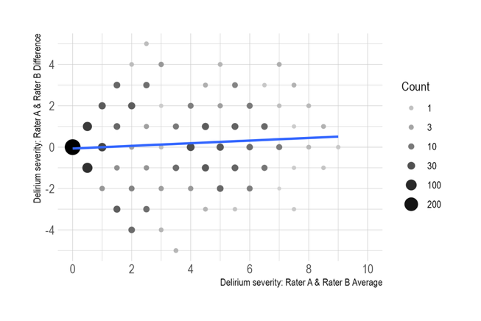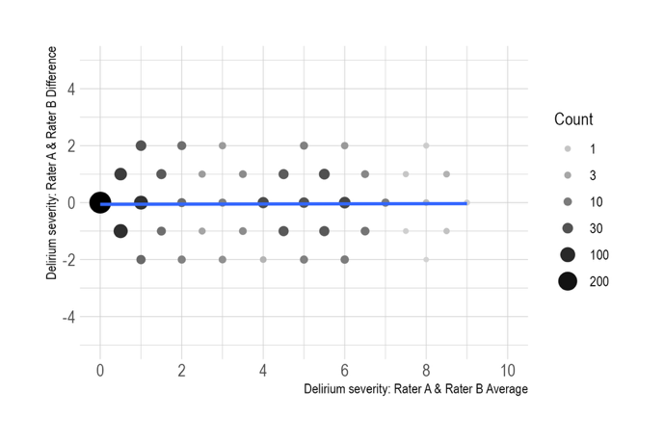
Figure 2. Bland Altman plot of variability in agreement as a function of delirium severity before (left panel), and after (right panel) consensus process. Differences in agreement (y-axis) are shown as a function of average severity ratings, comparing pairs of raters, before (left) and after (right) consensus process The linear trend lines show systematic differences in agreement. Regression coefficients are not importantly different from 0 in both panels b (95% confidence interval) = 0.03 (-0.13, 0.20) before and b = -0.01(-0.13, 0.12) after consensus process. This suggests there were no systematic differences in level of agreement across the spectrum of delirium severity.

